**CERTAINLY, HERE'S A TYPICAL STRUCTURE FOR A PROBLEM DEFINITION RELATED TO MEASURING ENERGY CONSUMPTION,INCLUDING THE INTRODUCTION, AIM, SCOPE, AND CONCLUSION:**

**INTRODUCTION:**

In today's world, with the ever-increasing demand for energy and the pressing need to address environmental concerns, measuring energy consumption has become a critical and multifaceted challenge. The accurate and efficient measurement of energy consumption is pivotal for individuals, businesses, and governments to optimize energy usage, reduce costs, and minimize their environmental footprint. This problem definition aims to outline the importance of measuring energy consumption, establish the specific goals and objectives, and provide an overview of the scope of this undertaking.

**ABSTRACT:**

Measuring energy consumption is a critical element of effective energy management. This problem definition outlines the importance of accurate energy measurement and its far-reaching implications. The aim is to provide a comprehensive view of the challenges, objectives, and scope related to energy consumption measurement, ultimately promoting informed decision-making for efficient energy usage.

**AIM:**

**1**.The primary aim of this study is to address the need for precise and comprehensive measurement of energy consumption. Specifically, we aim to:

**2**.Develop efficient and accurate methodologies and tools for measuring energy consumption across various sectors, including residential, commercial, and industrial.

**3**.Analyze the benefits of effective energy measurement, such as cost savings, carbon footprint reduction, and improved energy resource management.

**4**.Identify challenges and barriers in current energy measurement practices and propose solutions to overcome them.

**5**.Promote awareness and understanding of the significance of measuring energy consumption among individuals, organizations, and policymakers.

**SCOPES:**

This problem definition will encompass the following scopes:

**1**.Residential Energy Consumption: Investigating methods for measuring energy consumption in residential settings, including smart meters, home energy monitoring systems, and behavioural analysis.

**2.**Commercial Energy Consumption: Assessing energy measurement tools and techniques for businesses and commercial properties, considering advanced monitoring systems, real-time data analysis, and benchmarking.

**3**.Industrial Energy Consumption: Examining the challenges and complexities of measuring energy consumption in the industrial sector, focusing on process optimization, sensor technologies, and demand-side management.

**4**.Renewable Energy Integration: Exploring how energy consumption measurement can facilitate the integration of renewable energy sources into the grid and promote sustainable energy practices.

**5**.Policy and Regulations: Analyzing the role of government policies and regulations in shaping energy measurement standards and promoting energy efficiency.

**THE PROBLEM DEFINITION FOR MEASURING ENERGY CONSUMPTION TYPICALLY**

The problem definition for measuring energy consumption typically involves determining how much energy is being used by a device, system, or building over a specific period. The goal is to quantify and analyze energy usage for various purposes, such as energy efficiency improvements, cost savings, environmental impact assessments, or compliance with energy regulations. Here's a more detailed breakdown:

**PROBLEM STATEMENT:**

**OBJECTIVE:** Measure and analyze energy consumption in a specific context.

**INPUTS:**

**1.** **ENERGY DATA**: Collect data on energy usage, typically in the form of electricity, gas, or other relevant units. This data can come from utility bills, sensors, or monitoring equipment.

**2. TIME PERIOD:** Specify the time frame for which energy consumption will be measured (e.g., daily, monthly, annually).

**3.** **CONTEXT:** Define the scope of the measurement, which could be a single device, a building, an industrial process, or an entire facility.

**TASKS:**

**1.** **DATA COLLECTION:** Gather historical and real-time data on energy consumption. Ensure data accuracy and completeness.

**2. DATA PREPROCESSING:** Clean, format, and prepare the data for analysis. This may include handling missing values or outliers.

**3. ANALYSIS:** Apply statistical and analytical techniques to the data to derive insights and patterns in energy consumption.

**4. VISUALIZATION:** Create charts, graphs, or reports to visually represent energy consumption trends.

**5. MODELING:** Build predictive models if needed to forecast future energy consumption based on historical data.

**6. RECOMMENDATIONS:** Provide recommendations for energy efficiency improvements or optimization based on the analysis.

**7. REPORTING:** Present the findings and insights to stakeholders, which could include management, engineers, or policymakers.

**CHALLENGES:**

- Variability in energy consumption patterns.

- Identifying energy-efficient practices and areas for improvement.

- Data accuracy and reliability.

- Regulatory compliance and reporting requirements.

**APPLICATIONS:**

- Energy management in commercial and industrial settings.

- Home energy monitoring and conservation.

- Sustainability initiatives and carbon footprint reduction.

- Compliance with energy efficiency standards and regulations.

The specific problem definition will vary based on your context and goals, but this outline should give you a starting point for measuring energy consumption.

**BLOCK DIAGRAM:**

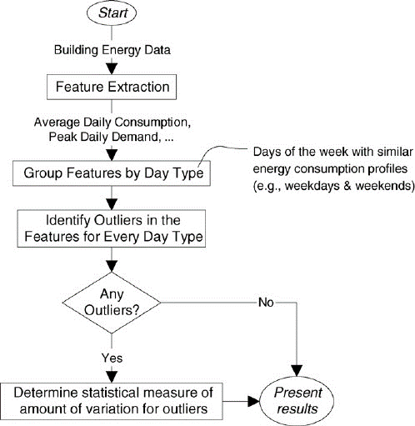

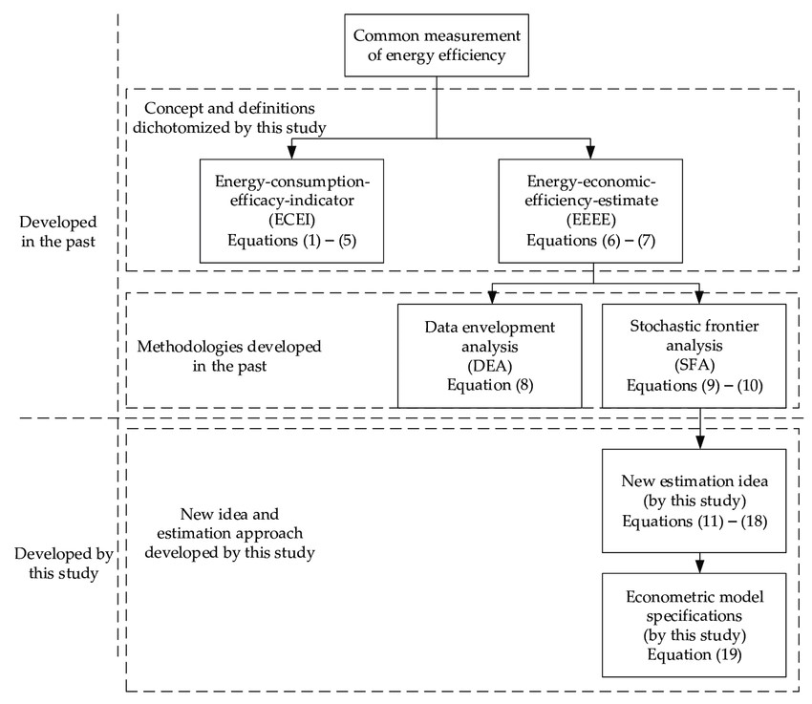

**CONCLUSION:**

In conclusion, the accurate measurement of energy consumption is a pivotal aspect of sustainable energy management and climate action. This problem definition underscores the critical need for precise energy measurement, outlines the key objectives of this study, and provides a clear understanding of the areas of focus. By achieving the outlined aims and scopes, we anticipate contributing to a more energy-efficient and environmentally responsible future, benefitting individuals, organizations, and society as a whole.

**DESIGNING A SYSTEM TO MEASURE ENERGY CONSUMPTION INVOLVES SEVERAL COMPONENTS AND CONSIDERATIONS. HERE'S A HIGH-LEVEL DESIGN FOR MEASURING ENERGY CONSUMPTION:**

Designing a system to measure energy consumption is a complex process that involves multiple components and considerations. Such a system is crucial for both individuals and organizations to understand how much energy they are using, identify patterns, and make informed decisions to improve energy efficiency, reduce costs, and meet regulatory requirements. Here's an explanation of the high-level design components for measuring energy consumption:

Measuring energy consumption is a crucial aspect of energy management. It involves the systematic quantification of energy use by devices, systems, or buildings over a defined time frame. This process is instrumental in helping organizations and individuals make well-informed decisions related to energy usage. Accurate measurement of energy consumption has a profound impact on several vital aspects, including energy efficiency, cost savings, environmental sustainability, and adherence to energy regulations. This problem definition aims to delve deeper into the significance of measuring energy consumption, elucidate its broader implications, and lay the foundation for a comprehensive study in this domain.

**BLOCK DIAGRAM:** 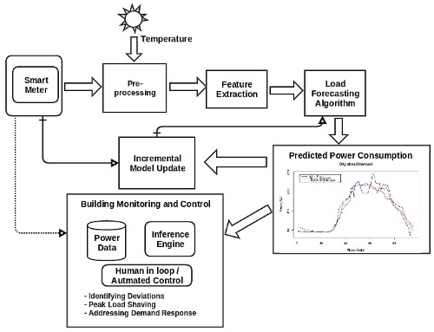

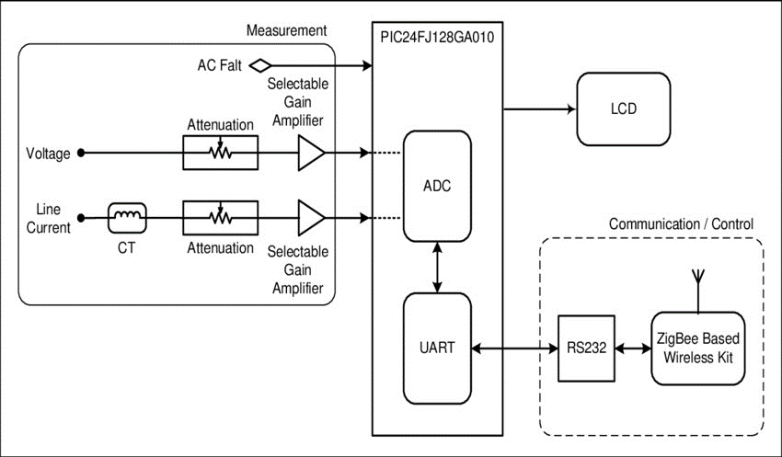

**CONCLUSION:**

In conclusion, the precise measurement of energy consumption stands as a linchpin in the broader landscape of energy management and environmental responsibility. This comprehensive problem definition underscores the crucial role that energy consumption measurement plays in optimizing energy usage, reducing costs, mitigating environmental impact, and adhering to regulatory frameworks. By pursuing the defined aims and scopes, we anticipate contributing significantly to a more sustainable and efficient energy future, benefitting individuals, organizations, and society as a whole.